Rowayton Green Team Sustainable Party Boxes
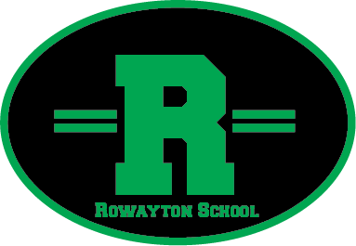

The Rowayton Green Team has created 2 Sustainable Party Boxes that you can now reserve for your class parties. Our goal is to reduce waste that our classroom parties create. We would like to set an example for our children by teaching them to reduce, re-use and recycle.

We currently have 2 boxes that are kept in the PTA closet in the basement. Each box contains the following:
24 Plates
24 Forks
24 Spoons
Water pitcher
Recyclable cups

How to use:
To reserve a box please sign up on the form above the party box with your name, cell phone number, date and time that you would like to use the box. The person who ‘checks out’ the box is responsible for taking the items home and running them through their dishwasher. Items should be dried and returned to the box and brought back to the school the next morning. Please be sure to wash the inside of the box before adding the clean items back inside.

We realize that we can only check out 2 boxes per day and that may be an issue during busy Holiday times. If these boxes prove to be a success we hope to add several more!

Thank you!
The Rowayton Green Team

