Rowayton Green Team Sustainable Party Box
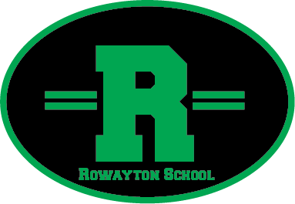

Please remember to return the clean contents and return the box to the PTA closet the following morning after your event.

Name | Cell Phone # | Date & Time of Party

